# JS Advanced Exam Retake

# Problem 01.Autumn Adventures

**Environment Specifics**

Please be aware that every JS environment may **behave differently** when executing code. Certain things that work in the browser are not supported in **Node.js**, which is the environment used by **Judge**.

The following actions are **NOT** supported:

* **.forEach()** with **NodeList** (returned by **querySelector()** and **querySelectorAll()**)
* **.forEach()** with **HTMLCollection** (returned by **getElementsByClassName()** and **element.children**)
* Using the **spread-operator** (**...**) to convert a **NodeList** into an array
* **append()** in Judge (use only **appendChild()**)
* **prepend()**
* **replaceWith()**
* **replaceAll()**
* **closest()**
* **replaceChildren()**
* Always turn the collection into a **JS array** (forEach, forOf, et.)

If you want to perform these operations, you may use **Array.from()** to first convert the collection into an array.

**Use the provided skeleton to solve this problem.**

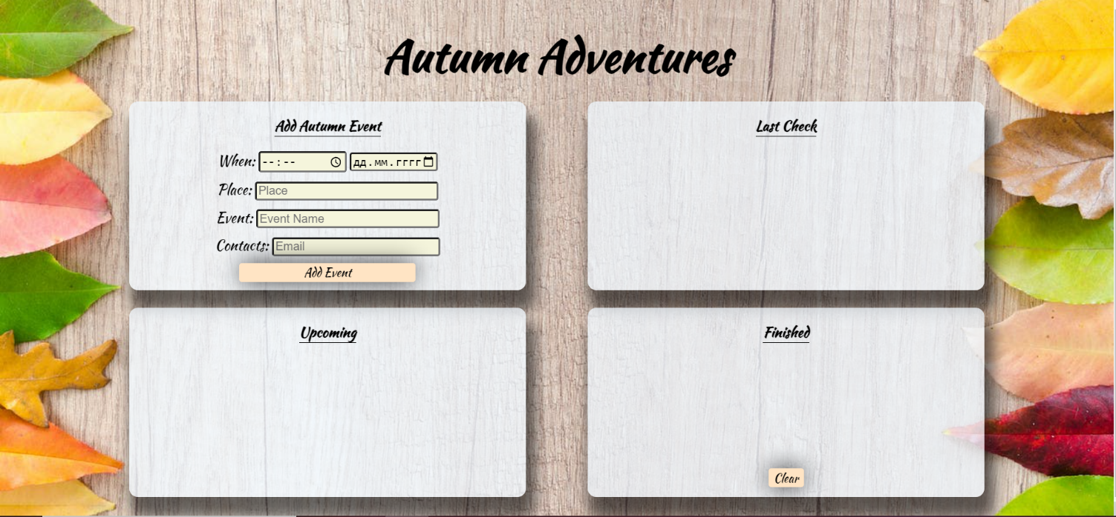**Write the missing functionality** of this user interface. The functionality is divided in the following steps:

**Your Task**

**Write the missing JavaScript code** to make the **Autumn Adventures** work as expected:

All fields **(Time, Date, Place, Event,** and **Contacts)** are **filled with the correct input**

* **Time, Date, Place, Event,** and **Contacts** are **non**-**empty** **strings**. If any of them is empty, the program should not do anything.

## 1. Getting the information from the form

• When the **["Add Event"]** button is clicked, the information from the input fields is listed in the "**Last Check**" section. A **list item** is added to the **"check-list"** unordered list.

* The list item should follow the same text format and order as shown in the provided picture.
* When the button is clicked, the **input** fields must be **cleared**, and the **["Add Event"]** button should be **disabled**. Additionally, the **"Edit"** and **"Continue"** buttons need to be added.

The HTML structure looks like this:

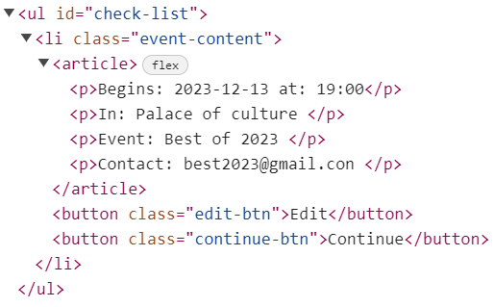

**2. Edit Event**

**The functionality here is the following:**

* **When the "**Edit" **button is clicked, all of the information is loaded into the input fields from step 1 and all the buttons in Last Check section are removed, while the** ["Add Event"] **button is enabled again.**

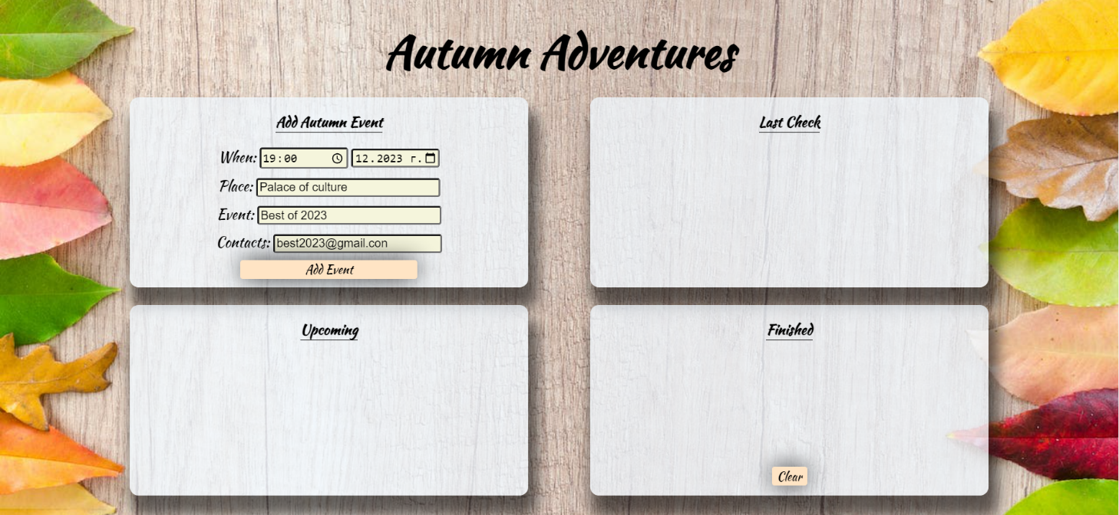

* **The list items must be removed from the** "check-list".



**3.Continue**

* **When the** "Continue" **button is clicked,** **the information from** "check-list" unordered list must be transferred to "upcoming-list" in the same HTML structure**. For you, this means removing everything inside of the** <ul> **with class =** "check-list" **and adding in** "upcoming-list" **the list item with same information. T**he "Move to Finished" button must be **added as well.**

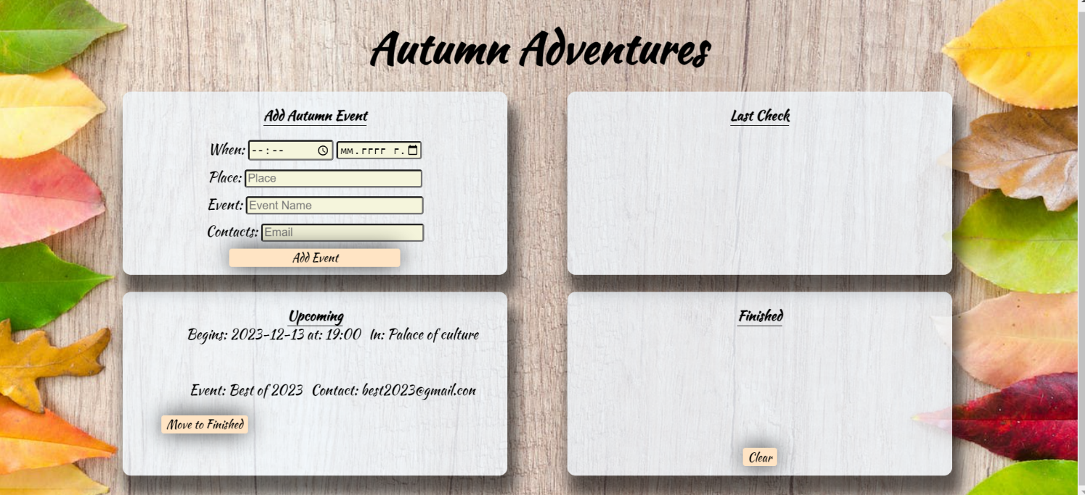

* **This is the HTML** structure **of the** "upcoming-list" unordered list**:**

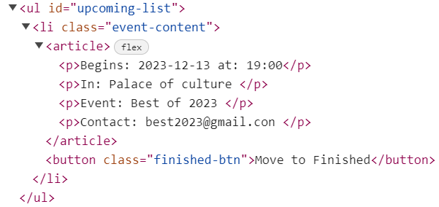

**3. Move to Finished**

* **When the** "Move to Finished" **button is clicked,** **the information from the** "upcoming-list" unordered list must be transferred to "finished-list" in the same HTML structure**. For you, this means removing everything inside of the** <ul> **with class =** "upcoming-list" **and adding into** "finished-list" **the list item with same information. The "Move to Finished” button must be removed.**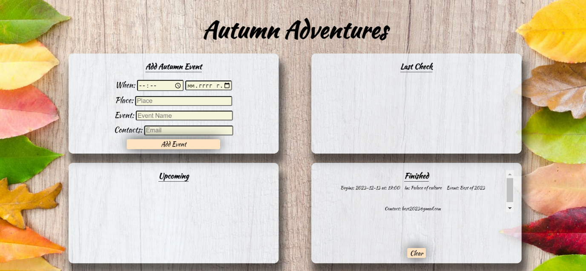

**4. Clear**

* **When the** "Clear" **button is clicked,** **the list item must be removed from the** "finished-list".
* "Clear" button:

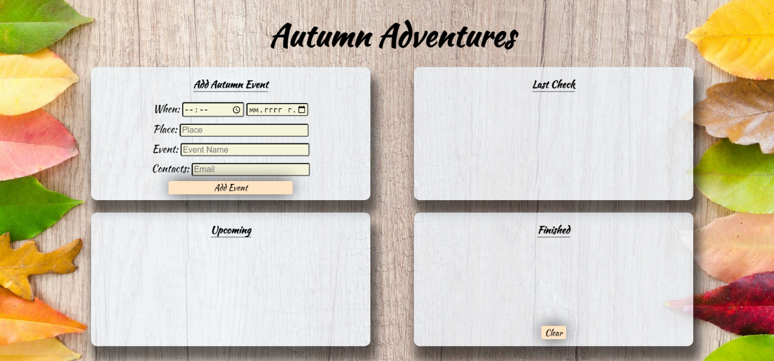

# Submission

Submit only yours **solve()** function.

*GOOD LUCK… ☺*